ORDER OF WORSHIP
* Indicates, please stand if able.
WELCOME, PASSING THE PEACE OF CHRIST, & ANNOUNCEMENTS

*CALL TO WORSHIP (Psalm 23, John 10)
L: Hear Jesus’s great truth: I am the gate for the sheep!
P: We recognize this voice. We’ve heard these words before.
L: Come in! You belong here! You are safe and cared for here!
P: We recognize the voice of our shepherd.
L: Follow and find green pastures and still waters!
P: We hear his voice.
L: I come to give life and give it abundantly.
P: Come one, come all!
*OPENING PRAYER (Acts 2, John 10)
Risen Savior, Reliable Shepherd, we hear your voice calling us to follow. We remember our ancient brothers and sisters who gathered in prayer and praise. Today, we too gather in prayer and praise. Enliven us with your resurrection power—a power that frees us from despair. Enliven us with your abundant life. May your living power flow through us in all we are and do! Amen.
*OPENING HYMN “Beauty of the Earth” UMH #92

CHILDREN’S TIME Tom Epps
JOYS AND CONCERNS
PRAYER OF CONFESSION (Psalm 130, John 11)
Loving Savior, Shepherd with the voice we know, be with us when we stray. For we often hear the voices of strangers and follow them to dry pastures and dark valleys. We forget your voice of love and begin to feel small and lost. We fear that we will not have enough to go on, much less have a surplus to offer others. And yet you know us by heart and by name. Call us once again. Restore our souls. Walk ahead of us on the right paths, and we will follow you. Remembering your voice, we pray. Amen.
WORDS OF ASSURANCE (Psalm 23)
Jesus is our gate. We will enter and be saved. Jesus is our shepherd. We will walk upon his paths. Jesus restores our souls, and makes us whole. Surely goodness and mercy shall follow us all the days of our lives. And we will dwell in the house of the Lord forever.
PASTORAL PRAYER Tom Epps
THE LORD’S PRAYER (In Unison)
Our Father, who art in heaven, hallowed be thy name. Thy kingdom come, thy will be done on earth as it is in heaven. Give us this day our daily bread. And forgive us our trespasses, as we forgive those who trespass against us. And lead us not into temptation, but deliver us from evil. For thine is the kingdom, and the power, and the glory, forever. Amen.
INVITATION TO THE OFFERING (Acts 2)
Some of the earliest memories of the church record acts of generosity, of meeting the needs of any and all. The church earned the goodwill of everyone who witnessed and experienced this gladness. Let us give with open hearts, as our ancient brothers and sisters did.
SPECIAL MUSIC “Going Home” (By: Paul Langford) Performed by Choir
*DOXOLOGY “Praise God, from Whom All Blessings Flow” UMH #95
OFFERTORY PRAYER
God of Abundant Life, Host of our Table, we devote ourselves and these gifts to your vision of a community that meets the needs of any and all. We give our gifts of money and work, of prayer and praise, of presence and purpose to our friends and neighbors. Bless our offering, that it may meet the needs, both small and large, of your great and generous blessings. Amen.
SCRIPTURE Psalm 121 Isaiah 2:1-5
*HYMN OF PRAISE “O Blessed Spring” UMH# 2076

MESSAGE “Keep Climbing” Tom Epps
*HYMN OF COMMITMENT “They’ll Know we are Christians” FWS # 2223

*BENEDICTION
L: Everyone was struck with awe by the signs and wonders of the early church.
P: This week, let’s show signs and wonders of our church.
L: The resurrection power of Jesus Christ, Shepherd of the Church, is upon us.
P: Jesus came that all may have life and have it abundantly!
L: Surely goodness and mercy shall follow us all the days of our lives!
P: May goodness and mercy flow from us.
POSTLUDE Matthew Schluntz

ANNOUNCEMENTS

WEDNESDAY CONNECTIONS: Designed for Christian Fellowship. Meal this week served
by the Youth Group
THE YOUTH LED WORSHIP: May 7th, 9am
PRAYER WALK: today and next Sunday at 1pm in parking lot.
National Day of Prayer, Thursday, May 4.
SMALL GROUP STUDY: “Living as United Methodist Christians” by Andy & Sally
Langford. 6 Sundays from May 7th at 10:30 am. Please sign up for this to order books.
SCRIP CARDS: When you are thinking of ideas for gift giving or personal use, consider Scrip cards.
Stop at the gathering area on Sundays or call Marcia at 715-284-3346
FELLOWSHIP: served today by Karen Pennekamp.
USHER/GREETERS: Alan & Paula Voskuil.
THIS WEEK AT THE CHURCH:
Mon: Trustees 5:00 pm Sat: UMM 8am
UWF 5:30pm
Wed: Wednesday Connections 4:45pm
Pre-Con 5-6 pm
Youth 6-7 pm
Confirmation Class 7-8 pm

Bible Verse of the Week: Hebrews 1:3

“Who being the brightness of his glory, and the express image of his person, and upholding
all things by the word of his power, when he had by himself purged our sins,
sat down on the right hand of the Majesty on high.”

Bible Trivia:

What was the father of Alexander and Rufus known for?
A. being cured from leprosy B. giving to the poor
C. arguing with Pharisees D. carrying Jesus` cross
see Mark 15:21

Black River Falls
United Methodist Church

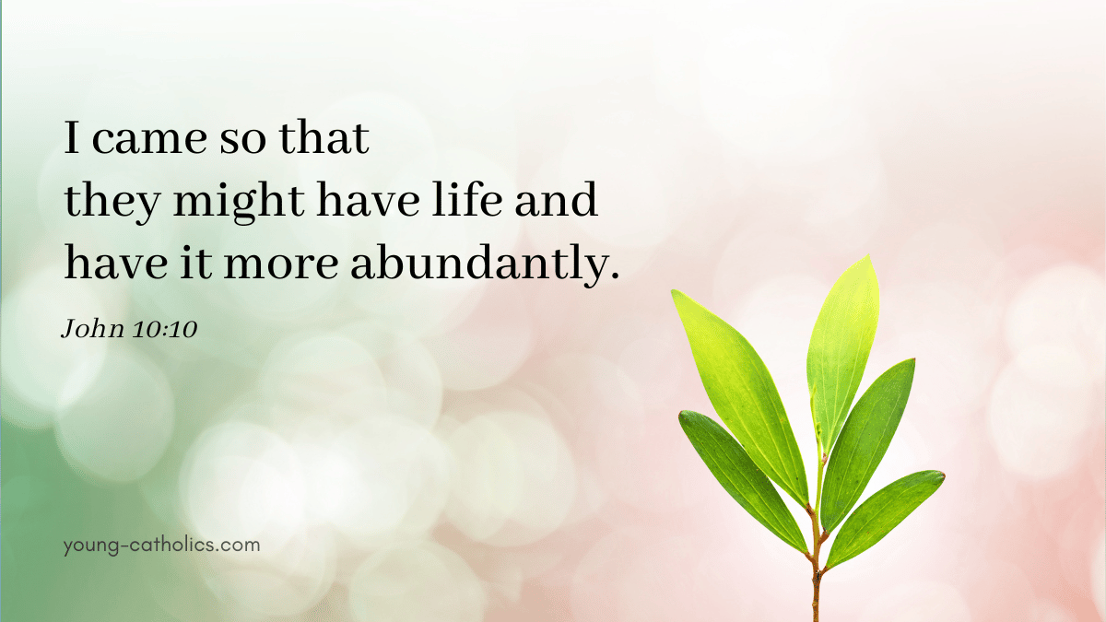

UMC Mission Statement:
"To make disciples of Jesus Christ for the transformation of the world.”

April 30, 2023
Fourth Sunday after Easter
Worship Leader: Tom Epps

PASTOR Rev. Inwha Shon
PIANIST Matthew Schluntz
MUSIC DIRECTOR Amanda Lang

100 North Fourth Street, Black River Falls, WI. 54615
Phone: 715-284-4114 Office Hours: Monday-Thursday, 9 am-2 pm
Website: brfumc.org & Black River Falls United Methodist Church Facebook
brfumc at YouTube

