YOUTH LED WORSHIP
May 7, 2023

ORDER OF WORSHIP
* Indicates, please stand if able.
WELCOME, PASSING THE PEACE OF CHRIST, & ANNOUNCEMENTS

OPENING SONG “Here I am to Worship”

*CALL TO WORSHIP
L: By faith, we trust that we were created in the image of God.
P: By faith, we hope and dream and make plans.
L: By faith, we face our fears and insecurities
P: By faith, we till the soil of our lives and plant seeds of love.
L: By faith, we follow where God leads.
P: By faith, we trust that God is present in our midst.
A: By faith, we gather in this place to worship God together.

*OPENING PRAYER
God of infinite wisdom, you have been faithful to your people
throughout time. Calm our minds. Open our ears and our hearts this
day so that we might still hear of your faithfulness. In Your name
we pray. Amen.

*OPENING HYMN “10,000 Reasons”

JOYS AND CONCERNS
PRAYER OF CONFESSION
Almighty God, we are not always people who live by faith. We know
that we were created in your image, but we treat ourselves and each other in ways that do not honor your presence within us. We hear your call to reach out to those most in need but neglect the call to help. Forgive us O God, and help us day by day to become more faithful followers and the people you create us to be. In the name of Your Son, Jesus Christ, we pray, Amen.

Prayer for the Youth
THE LORD’S PRAYER (In Unison)
Our Father, who art in heaven, hallowed be thy name. Thy
kingdom come, thy will be done on earth as it is in heaven.
Give us this day our daily bread. And forgive us our trespasses,
as we forgive those who trespass against us. And lead us not
into temptation, but deliver us from evil. For thine is the kingdom,
and the power, and the glory, forever. Amen.

Children’s Message Lauren Beck
OFFERING SONG
Special Music: Channing Goldsmith, Katrina McGillivray
*DOXOLOGY “Praise God, from Whom All Blessings Flow UMH #95
OFFERTORY PRAYER
SCRIPTURE Philippians’ 4: 6-7
Do not be anxious about anything, but in every situation, by
prayer and petition, with thanksgiving, present your requests to
God. And the peace of God, which transcends all understanding,
will guard your hearts and your minds in Christ Jesus.
1 Timothy 4: 12
Don’t let anyone think less of you because you are young.
Be an example to all believers in what you say, in the way you
live, in your love, your faith, and your purity.

MESSAGE Macie Goldsmith, Channing Goldsmith, Iris Zenz
*HYMN OF PRAISE “Reckless Love”

COMMUNION UMH #12-15
SPECIAL OFFERING
BRF Foster Closet, Angel School Lunch Program

*BENEDICTION Pastor Inwha
HYMN “I Can Only Imagine”

ANNOUNCEMENTS
WEDNESDAY CONNECTIONS: Designed for Christian Fellowship. Meal
this week served by Mission Outreach.
PRAYER WALK: today and next Sunday at 1pm in parking lot.
SMALL GROUP STUDY: “Living as United Methodist Christians” by Andy
& Sally Langford. 6 Sundays from May 7th at 10:30 am. Please sign up for
this to order books.
SCRIP CARDS: When you are thinking of ideas for gift giving or personal
use, consider Scrip cards. Stop at the gathering area on Sundays or call
Marcia at 715-284-3346
FELLOWSHIP: served today by Imelda Kelly.
USHER/GREETERS: Youth Group

THIS WEEK AT THE CHURCH:
Wed: Wednesday Connections 4:45pm-6pm
Pre-Con 5-6 pm
Youth 6-7 pm
Confirmation Class 7-8 pm
Sat: UMM 8 am

Bible Verse of the Week: Hebrews 1:3
“Who being the brightness of his glory, and the express image of his person, and upholding
all things by the word of his power, when he had by himself purged our sins,
sat down on the right hand of the Majesty on high.”

Bible Trivia:
What was the father of Alexander and Rufus known for?
A. being cured from leprosy B. giving to the poor
C. arguing with Pharisees D. carrying Jesus` cross

see Mark 15:21

Black River Falls
United Methodist Church

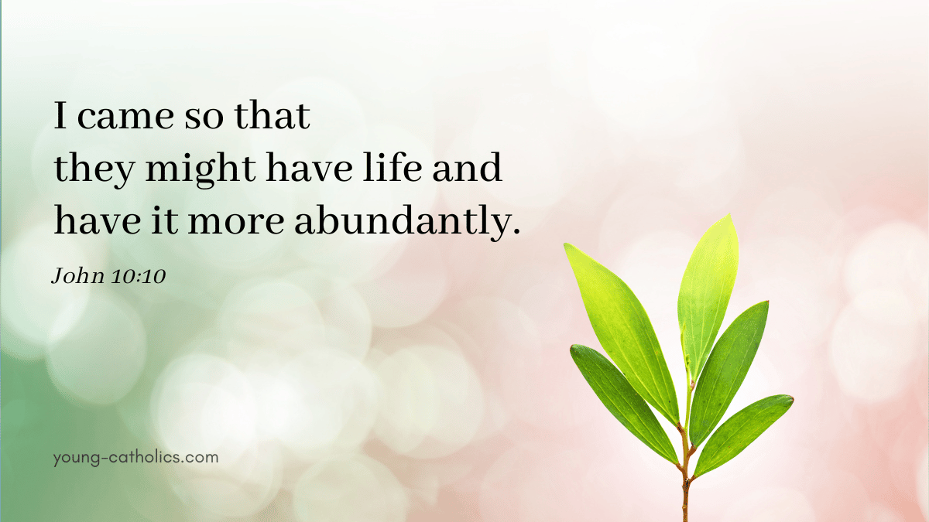

UMC Mission Statement:
"To make disciples of Jesus Christ for the transformation of the world.”

PASTOR Rev. Inwha Shon
PIANIST Matthew Schluntz
MUSIC DIRECTOR Amanda Lang

100 North Fourth Street, Black River Falls, WI. 54615
Phone: 715-284-4114
Office Hours: Monday-Thursday, 9 am-2 pm

Website: brfumc.org & Black River Falls United Methodist Church Facebook
brfumc at YouTube

