ORDER OF WORSHIP
* Indicates, please stand if able.
Fifteenth Sunday after Pentecost September 10, 2023, 9 am
Liturgist: Chuck Devendorf

WELCOME, PASSING THE PEACE OF CHRIST, & ANNOUNCEMENTS

*CALL TO WORSHIP
L: Come out of the darkness of despair into the brightness of God’s transforming love.
P: We praise God for God’s presence with us!
L: Prepare your hearts and spirits to receive God’s mercy and healing.
P: We thank God for God’s mercy toward us.
L: Come, let us praise and worship God who is always with us.
P: Thanks be to God at all times and in all places. AMEN.
*OPENING PRAYER
Gracious God, we come this day seeking courage and hope for the future. Our world is in such peril. Heal these wounds and quiet the words of war. Help us to be those who bring peace in our families and communities. Banish the darkness of doubt and fear; anoint us with your light and love that we may spread the good news of your mercy to everyone. In Jesus’ name, we pray. AMEN.
*OPENING HYMN Celebrate Love TFWS #2073
JOYS AND CONCERNS
PRAYER OF CONFESSION (Exodus 12, Romans 13, Matthew 18)
Gracious God, amidst our songs of joy, our hearts are touched by fear. Sin plagues our world, even as we strive to build your realm. Sorrow enters our lives, even as we put on false smiles and engage in empty conversations. Death lurks around every corner, even as we struggle against our own mortality. Reconcile us with your love and compassion, and bless us with your compassionate presence, that we may be filled with joy, love, and hope this day. Amen.
WORDS OF ASSURANCE (Romans 13, Matthew 18)
Wherever two or three are gathered in Christ’s name, God is with us. Where God is, grace and compassion abide. In the grace of God and the love of Christ, we are made one in ministry to the world.

PASTORAL PRAYER Rev. Shon
THE LORD’S PRAYER (In Unison)
Our Father, who art in heaven, hallowed be thy name. Thy kingdom come, thy will be done on earth as it is in heaven. Give us this day our daily bread. And forgive us our trespasses, as we forgive those who trespass against us. And lead us not into temptation, but deliver us from evil. For thine is the kingdom, and the power, and the glory, forever. Amen.
INVITATION TO THE OFFERING (Exodus 12, Romans 13)
In Christ, all gifts are welcome, both great and small. Bathed in love, led by compassion, let us share our gifts and offerings with God.
*DOXOLOGY Praise God, from Whom All Blessings Flow UMH #95
*OFFERTORY PRAYER Rev. Shon
SCRIPTURE Matthew 28:19-20 // 2 Corinthians 5:20
¹⁹ Therefore go and make disciples of all nations, baptizing them in the name of the Father and of the Son and of the Holy Spirit, ²⁰ and teaching them to obey everything I have commanded you. And surely I am with you always, to the very end of the age.”
²⁰ We are therefore Christ’s ambassadors, as though God were making his appeal through us. We implore you on Christ’s behalf: Be reconciled to God.
*HYMN OF PRAISE The Summons TFWS #2130
SERMON Rooted In Sharing Rev. Shon
BAPTISM Maddie Foster
*CLOSING HYMN Walk with Me TFWS #2242
*BENEDICTION Rev. Shon
POSTLUDE

Bible Verse of the Week: Isaiah 48:17
“This is what the Lord says— your Redeemer, the Holy One of Israel: “I am the Lord your God, who teaches you what is best for you, who directs you in the way you should go.”
ANNOUNCEMENTS

PRAYER REQUESTS: Please pray for people in need in our church, community, nation,
and the World.
UNITED WOMEN IN FAITH: Mon., Sept., 11th at 5 pm, will be having a “Bring your own
Environmentally Friendly Bag Lunch” followed by a presentation at 6 pm by Andrew Epps.
WEDNESDAY CONNECTIONS: will begin Sept., 13th at 5 pm. Meal will be served by
Esther Shon. A signup sheet is on the kitchen entrance door, please volunteer if you can!
YOUTH GROUP: The first weekly meeting is on Wed., Sept. 13th at 5:30 pm-7:00 pm.
CONFIRMATION DAY: will be on Sunday, Sept., 17th at 9 am.
BIBLE STUDY: “Living as United Methodist Christians” will begin Sept., 17th at 10:30 am.
and will last 6 weeks. Facilitator: Pastor Inwha.
BIBLE STUDY: “Invitation to the Old Testament.” The prep meeting will be on Sunday,
Sept., 17th at 10:15 am in the library. 8-week study. Facilitator: Paula Voskuil.
UNITED METHODIST MEN: Sat., Sept. 23rd at 8 am, will need volunteers for tree removal
in the East parking lot. Please contact Paul Hoffman or just show up!
ROOTED: A new sermon series begins Sept. 10 – Oct. 1. Bring your family, neighbors, and
friends to Christ.
SMALL GROUPS: If you are interested in leading small groups, please contact the office.
The first prep meeting will be on Tuesday, Sept. 19th at 5:30 pm.
GOLF OUTING: will be held on Sunday, Sept. 24th at 1 pm at Skyline. Potluck afterwards.
CHURCH FAMILY REUNION: will be on Sunday, October 1st.
SCRIP CARDS: When you are thinking of ideas for gift-giving or personal use, consider
Scrip cards. Stop at the gathering area on Sundays or call Marcia at 715-284-3346
USHER/GREETERS: Jim Bible and Imelda Kelly
FELLOWSHIP: Judy Sheppard

MEETINGS
Today Mission Outreach 10:30 am
Mon. Sept. 11 UWF/Trustees 5:00 pm
Tue. Sept. 12 Worship/Ad Council 5:30 pm/6:30 pm
Wed. Sept. 13 Youth Group 5:30 pm-7 pm
Tue. Sept. 19 Small Group Ministry 5:30 pm
Tue., Sept. 26 SPRC 5:30 pm

Bible Trivia

Complete this verse: "By the rivers of Babylon, there we sat down, yea, we wept,
when we remembered ______."
- God B. Bethlehem C. Egypt D. Zion See: Psalm 137:1

Black River Falls
United Methodist Church

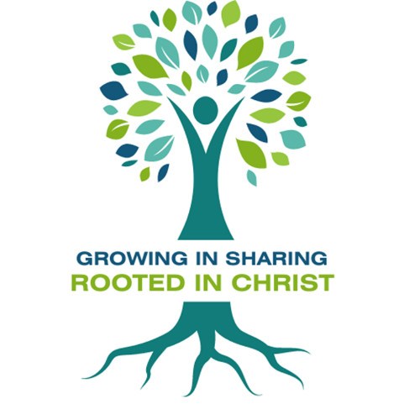

UMC Mission Statement:
"To make disciples of Jesus Christ for the transformation of the world.”

PASTOR Rev. Inwha Shon

100 North Fourth Street, Black River Falls, WI. 54615
Phone: 715-284-4114 Office Hours: Monday-Thursday, 9 am-2 pm
Website: brfumc.org
Facebook: Black River Falls United Methodist Church
YouTube: brfumc

