ORDER OF WORSHIP
* Indicates, please stand if able.
Third Sunday of Advent December 17, 2023, 9 am
Liturgist: Roxie Hostrawser

WELCOME, PASSING THE PEACE OF CHRIST, & ANNOUNCEMENTS
*CALL TO WORSHIP
L: Love has come down to us this Advent Season.
P: Divine love which heals and transforms our lives.
L: With great joy, we receive that love and share it with others.
P: We open our hearts to all God’s children, the last, the least, and the lost, as well as those who feel privileged.
L: The Lord has done and continues to do great things for us.
P: Praise be to God who loves us so much and who challenges us to be people of joy in this darkened world. AMEN.

LIGHTING OF ADVENT CANDLE #3: Iris, Eric & Kyle Zenz
Reader 1: When God’s people were surrounded by hardship, suffering, and grief, Isaiah proclaimed,
The spirit of the Lord GOD is upon me, because the LORD has anointed me; he has sent me to bring good news to the oppressed, to bind up the brokenhearted, to proclaim liberty to the captives, and release to the prisoners; to proclaim the year of the Lord's favor, and the day of vengeance of our God; to comfort all who mourn; to provide for those who mourn in Zion—to give them a garland instead of ashes, the oil of gladness instead of mourning, the mantle of praise instead of a faint spirit (Isaiah 61:1-3a).
Reader 2: We come today as people who are also surrounded by suffering and grief. And yet, the Spirit hovers among us, tending and anointing, inspiring freedom where there is captivity, declaring blessing in places the world has cursed, and igniting fierce joy where mourning and heartache prevail.
Congregation: We wait as people who experience hardship and pain, yet we are called to witness to the persistent joy that sustains our life as God’s people.
Reader 1: We light these candles as signs of our shocking hope, just peace, and fierce joy. May our lives shine with the fierce, tenacious joy of the Light who lives in our hearts as we wait and work for the coming of God’s kingdom on earth as it is in heaven. Amen.
CONGREGATION: “Come, O Come, Emmanuel” (v.3) UMH #211
*OPENING PRAYER (Psalm 126, Isaiah 61)
God of Dreams, you have done great things for your people. From times of old, you awaken the faithful to the dawn of your glory. Fill our mouths with laughter. Loose our tongues with shouts of joy. Anoint us with the oil of gladness and make it known among all people that we will live as oaks of righteousness, the plantings of the Lord. Amen.

*OPENING HYMN Blessed Be the God of Israel UMH #209
CHILDREN'S TIME Roxie Hostrawser
JOYS AND CONCERNS

PRAYER OF CONFESSION
Patient and forgiving God, you know how we want to be people of peace and justice, but when opportunities come to participate in groups working for justice, we turn our backs and walk the other way, or we give a token pledge and then ignore further pleas for assistance. We hide our names from appearing on roles of supporters of justice-seeking organizations. Forgive us, O God, when we give only lip service to ministries of justice rather than pledging our lives to helping all people in need. Free us from our selfishness. Banish our fears and move us in ways of peace and justice, bringing your love and hope to all God’s children. We ask these things in God’s name. AMEN.
WORDS OF ASSURANCE (Ephesians 1)
Rejoice! You who once lived in darkness – on you a new light is shining and the light of God’s glory shall brighten your path. You are healed, loved and forgiven. Be at peace! Live in God’s love, and bring hope and justice to all God’s people. AMEN.
PASTORAL PRAYER Rev. Shon
THE LORD’S PRAYER (In Unison)
INVITATION TO THE OFFERING
*DOXOLOGY Praise God, from Whom All Blessings Flow UMH #94
*OFFERTORY PRAYER Rev. Shon
SCRIPTURE John 1:6-8

⁶ There was a man sent from God whose name was John. ⁷ He came as a witness to testify
concerning that light, so that through him all might believe. ⁸ He himself was not the light; he came only as a witness to the light.

*HYMN OF PRAISE I Want to Walk as a Child of the Light UMH #206
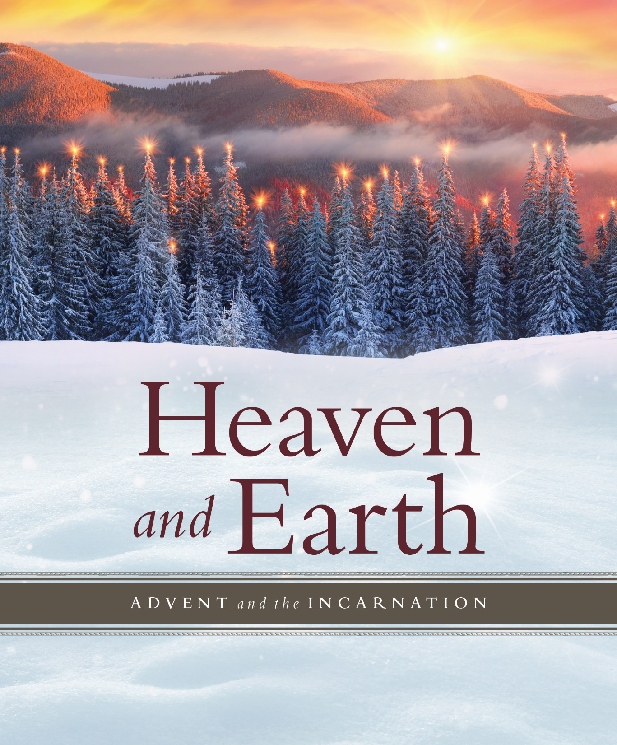
SERMON Light Rev. Shon
*CLOSING HYMN The Summons TFWS #2130
*BENEDICTION Rev. Shon

ANNOUNCEMENTS
PRAYER REQUESTS: Please pray for people in need in our church, community, nation,
and the World.
STEWARDSHIP CAMPAIGN: for the upgrade of the sound and video system at the
Sanctuary, boilers replacement, and next year’s church budget.
WEDNESDAY CONNECTIONS: Meal served by Esther Shon at 5:00 pm.
DINNER CHURCH: Team members wanted. Also looking for a donation of small/upright
freezer in good working condition. Contact Pat Moe at 715-896-6394
ALTERNATIVE GIVING TREE: Donations may be placed in the offering plate or sent to
church office. Needed by December 29th to be included in end of year giving.
VOLUNTEER SNOW SHOVELER: Sidewalks and entrances. If interested, contact Pat
Moe at 715-896-6394.
NEWLETTER DEADLING: Please submit information to the office by December 22nd.
NEW MEMBER CLASS: Beginning January 14, 2024.
SEWING GROUP: January 17, 2024 10 to 3:00 pm Sewing Pillowcase Dresses.
USHER/GREETERS: Dave and Sherry Olson
FELLOWSHIP: Joe & Maria Williams

UPCOMING MEETINGS

Sun Dec. 24 Christmas Eve Candlelight Service 5:00 pm

BLACK RIVER FALLS
UNITED METHODIST CHURCH

UMC Mission Statement:
"To make disciples of Jesus Christ for the transformation of the world.”

PASTOR Rev. Inwha Shon

100 North Fourth Street, Black River Falls, WI. 54615
Phone: 715-284-4114 Office Hours: Monday-Thursday, 9 am-2 pm
Website: brfumc.org YouTube: brfumc
Facebook: Black River Falls United Methodist Church

